**Department of Computing**

**Professional Software Projects**

**(55-508208-AF-20245)**

**Software Requirement Specification**  

**Project:** Elanco - Cloud-Based Cognitive Services to monitor Animal Behaviour

**Team ID:** Elanco2

**Team Members:**

| Name | ID |
| --- | --- |
| Alex Pantus | C3076001 |
| Sebastian Tarabadi | c3027828 |
| Lenisha Kehoe | c3020961 |
| Ariba Naveed | c3011163 |
| Ben McDonnell | c3035848 |

**Table of Contents**

Introduction 3

Project Overview 3

Project Objectives 3

System Requirements 4

Non-Functional Requirements 4

User Roles 4

Personas 6

User Stories 7

System Architecture 8

C4 Context Diagram (level 1): 8

C4 Container Diagram (level 2): 8

Appendix 1: Tasks Completed 9

Appendix 2: GitHub Repository 10

References 11

# Introduction

## Project Overview

Project Summary:

*‘To explore the use of cloud-based cognitive services to investigate how computer vision could be used to automate the categorisation of animal activities and behaviour; Where the resultant technology could have applications in animal monitoring, product development, and the customer experience.’*

The nature of the Project is rather abstract, however a sensible overview can be derived - Our Project will utilise existing pre-trained AI models and cloud-based APIs to provide an analysis on a user-submitted image of an animal, our web-based prototype will then categorise the activities and behaviours of the animal based on clues present in the submitted image. For example, our program can predict animal behaviour such as ‘aggressive’ based on a simple image.

**Problem Statement**

Images of animals contain valuable insight into their behaviours, health-status, activity patterns, and more. However, manually analysing these images to obtain results is time consuming and as the size of the data being processed increases, as does the margin of human error; the lack of an efficient way to analyse and categorise these images is resulting in a slowing effect being cascaded upon research being carried out. We need to develop a working prototype that is capable of using AI to analyse and categorise these characteristics and behaviours of animals, thus automating this categorisation process resulting in a much faster data analysis time and a lesser margin of error.

## Project Objectives

* To allow users to upload images of animals and then have the program provide them with a response in relation to the state of the animal’s behaviour, its characteristics, and its disease-status/health risk.
* To be able to categorise and group the results of each user’s submitted image using a selection of tags, e.g. Horse, Healthy, Drinking
* To be able to provide an accurate response for as many images as possible
* To provide a faster/more efficient way of providing correct observations of images when compared to that of a human carrying out the task

# System Requirements

## Non-Functional Requirements

More specific metrics to be added to measure the non-functional requirements

*Table 2: Non-Functional Requirements Indicative Examples*

| ID | Theme | Description | Priority (MoSCoW) |
| --- | --- | --- | --- |
| NFR01 | Performance | Optimize the speed of image analysis and categorization to provide quick responses to users. Target 1 second response | Should |
| NFR02 | Reliability | Design the system to provide consistent and accurate results under various operating conditions, including different image resolutions or qualities. | Must |
| NFR03 | Usability | Create a user-friendly interface for non-technical users to upload and review images and their categorised behaviours. | Must |
| NFR04 | Scalability | Ensure the system can handle a large number of images simultaneously, making it suitable for larger-scale positioning in the future. | Should |
| NFR05 | Maintablility | Write clean, modular, and well-documented code to allow future developers to understand and enhance the system easily. | Must |
| NFR06 | Resource Efficiency | Optimise cloud resource usage to minimise costs while maintaining high performance. | Should |
| NFR07 | Accessibility | Ensure compatibility with assistive technologies such as screen readers, high-contrast modes, and keyboard navigation. | Should |
| NFR08 | Accuracy | Achieve a high level of precision in categorising animal activities and behaviors, aiming for a minimum accuracy threshold of 90%. | Should |

## User Roles

| Role | Description |
| --- | --- |
| General User* | General users who have access to the software and its service  **Responsibilities:**   * Ability to Upload images * Ability to view provided Tags, Description, and any other form of provided categorisation observed from the image |
| Pet owner | A pet owner wants to have information about their pet that could denote an illness.  E.g. : if the tags are dog, lethargic, laying =would mean they should contact a vet or link a resource  cat, playing , sociable would mean the animal is healthy |
| Farmer | A farmer uses the software to monitor livestock and identify potential health or environmental issues.  **Responsibilities:**   * Upload images of livestock and surroundings. * View tags and descriptions related to animal health, posture, and environment. * Receive alerts if visual cues indicate signs of illness, injury, or poor living conditions. * Identify environmental factors like grazing conditions, pasture quality, or overcrowding. |
| Vet | A veterinarian uses the software to assist in diagnosing animal health issues based on visual indicators.  **Responsibilities:**   * Analyze uploaded images of animals to identify symptoms like abnormal posture, visible injuries, or signs of distress. * Provide health assessments based on visual evidence. * Recommend treatments or further examinations when visual indicators suggest illness. * Offer guidance to farmers and pet owners using detected visual tags. |

## 

# Personas

## Vets

| **Priya Sharma** | |
| --- | --- |
| * Age: 28 * Occupation: Veterinary Researcher * Location:Cambridge, UK * Quote: “I need a tool that helps me analyse animal behavior trends across various species quickly.” | |
| **Background** | Priya works as a researcher at a university veterinary program, focusing on animal behavior and welfare. She uses cutting-edge technology for her studies and is comfortable with cloud-based tools and APIs. Priya often analyzes large datasets and images to identify behavioral trends in different animals, such as stress levels or activity patterns. |
| **Scenario** | Priya uploads a dataset of 100 animal images to the system, looking to classify behaviors like “feeding,” “resting,” and “interacting.” The platform provides detailed categorization results with timestamps, which Priya uses to identify patterns and include in her published research paper. |

## 

| **Dr. Emily Reynolds** | |
| --- | --- |
| * Age: 38 * Occupation: Veterinarian * Location:Cambridge, UK * Quote: "Early detection of health issues can make all the difference for an animal's well-being." | |
| **Background** | Emily is an experienced veterinarian who works at a busy animal clinic. She uses technology to help diagnose health issues and monitor patients remotely when possible. With limited time, she values tools that provide quick, reliable insights to aid in diagnosing and recommending treatment plans. |
| **Scenario** | A pet owner uploads an image of their dog labeled with tags like “dog,” “lethargic,” and “laying.” Using the system’s insights, Emily advises the owner to bring the dog in for an examination, leading to the early detection and treatment of an underlying health condition. The system also helps her monitor post-treatment recovery through follow-up image uploads, ensuring the dog returns to its normal, active state. |

## Farmers

| **Emily Ruckus** | |
| --- | --- |
| * Age: 26 * Occupation: new dairy farmer * Location: Somerset, UK * Quote: “i’m just starting out and need all the help i can get to keep my animals healthy” | |
| **Background** | Emily recently inherited her family’s small dairy farm but has limited experience in managing livestock health. She's eager to learn and uses technology to make up for his lack of knowledge. A friend recommended Elanco’s platform as a way to monitor cows and spot early signs of disease. She uses it regularly as a learning tool and safety net to ensure her herd remains productive. |
| **Scenario** | While performing her morning checks, Emily notices one of her cows limping and behaving lethargically. unsure what's wrong, she takes a photo of the cow's leg and uploads it to the Elancos app. The AI suggested the cow may have early signs of food rot and recommended a course of action. Emily contacts her vet for confirmation, saving time and preventing the disease from spreading to other cows. |

## 

## 

| **David Carter** | |
| --- | --- |
| * Age: 45 * Occupation: Livestock Farmer * Location: Dorset, UK * Quote: “If this system can help me monitor my animals without being physically present all the time, it’d be a game-changer.”” | |
| **Background** | David owns a medium-sized livestock farm with over 100 cattle and 50 sheep. Managing the health and behavior of his animals is critical, but monitoring them manually is time-consuming and physically demanding. David uses basic farm management software and smartphones but is not tech-savvy. He needs tools that simplify animal behavior monitoring to save time and improve livestock health outcomes. |
| **Scenario** | David uploads images from his farm camera system to the platform, looking for insights into the behavior of a herd of cattle that has been acting unusually. The system identifies signs of lethargy and groups of isolated animals, flagging possible health concerns. David uses these insights to contact his vet for early intervention. |

## 

## Pet Owner

| **Sarah Thompson** | |
| --- | --- |
| * **Age:** 32 * **Occupation:** Teacher * **Location:** Manchester, UK * **Quote:** *"I just want to make sure my dog is happy and healthy."* | |
| **Background** | Sarah is a dedicated pet owner who loves her Golden Retriever, Max. With a busy schedule, she relies on technology to help monitor Max’s well-being. She often takes photos of Max and is curious if certain behaviors in the images could indicate health issues. Sarah values quick, reliable feedback that helps her make informed decisions about Max's care. |
| **Scenario** | Sarah notices Max lying down more than usual and looking tired. She uploads a recent photo of Max using the image recognition system. The system tags the image with “dog,” “lethargic,” and “laying,” along with a message suggesting she consult a vet if the behavior persists. Reassured by the prompt feedback, Sarah books a vet appointment to ensure Max’s health. |

## 

| **James Carter** | |
| --- | --- |
| * **Age:** 45 * **Occupation:** Software Engineer * **Location:** Leeds, UK * **Quote:** *"Keeping my pets healthy is a top priority, but I also want to know when things are normal."* | |
| **Background** | James is a tech-savvy pet owner with two cats, Luna and Milo. He enjoys capturing moments of their playful antics and uses technology to monitor their health. With a demanding job, James values tools that provide quick, accurate insights into his pets' well-being. |
| **Scenario** | After noticing Luna playing less frequently, James uploads a photo to the system. The tags “cat,” “resting,” and “calm” indicate typical feline behaviour, reassuring him that Luna is simply relaxing. A week later, he captures a video of both cats chasing toys, with tags like “cat,” “playing,” and “active,” confirming they are healthy and happy. |

## 

## 

## 

## 

## 

## 

## 

## User Stories

| **Title**: Upload Photos | **Priority**: Must | **Estimate:** 5 points |
| --- | --- | --- |
| As a horse trainer, I want to upload images of my horses so that I can analyse their behaviour using AI. Changes in behaviour can indicate the start of small issues, so being able to analyse them can be crucial for monitoring my horses’ health | | |
| **Acceptance Criteria**  **Given** I am on the upload page  **When** I select an image and click upload  **Then** the system should:   * Allow me to select files from my device (drag and drop or file selection), * Validate that the file is in the correct format e.g. JPEG and it doesn’t exceed the upload capacity e.g. 7MB * Display a progress bar while uploading * Confirm successful upload with message * Reject unsupported file formats/sizes and give the user a message of the error | | |

## 

| **Title**: Analyse Media | **Priority**: Must | **Estimate:** 12 points |
| --- | --- | --- |
| As a user, I want the AI system to analyse the uploaded images so that I can categorise animal behaviour. | | |
| **Acceptance Criteria**  **Given** I have uploaded an image/video  **When** I click the analyse button  **Then** the system should:   * Use the AI API we have chosen to categorise the animal behaviour * Accurately detect the behaviour/behaviours in the images * Display the behaviour/behaviours it sees to the user * Provide a brief explanation message as to why it sees this behaviour * Allow me to re-run the analysis to see if the results are consistent | | |

## 

| **Title**: Upload Videos | **Priority**: Could | **Estimate:** 4 points |
| --- | --- | --- |
| As a user, I want to upload videos of animals to analyse their behaviour | | |
| **Acceptance Criteria**  **Given** I have uploaded an video  **When** I click the analyse button  **Then** the system should:   * Allow me to select files from my device (drag and drop or file selection), * Validate that the file is in the correct format e.g. MP4 and it doesn’t exceed the upload capacity e.g. 20MB * Display a progress bar while uploading * Confirm successful upload with message * Reject unsupported file formats/sizes and give the user a message of the error | | |

## 

| **Title**: Analysis History | **Priority**: Should | **Estimate:** 8 points |
| --- | --- | --- |
| As a user, I want the to see the history of analyses I’ve done | | |
| **Acceptance Criteria**  **Given** I am on the view analysis history tab  **When** I select a previous analysis  **Then** the system should:   * Display the results from my previous analyses * Allow me to click on it to view more details on a particular analysis * Allow me to scroll through the rest of my analyses * Ensure my images aren’t stored as that goes against GDPR | | |

## 

| **Title**: Store History | **Priority**: Should | **Estimate:** 4 points |
| --- | --- | --- |
| As a user, I want my analyses to be stored in history | | |
| **Acceptance Criteria**  **Given** I have uploaded an image/video  **When** I agree to commit a search to history  **Then** the system should:   * Store the date, time and outcome of the search * Store the Search ID * Store the Analysis Results | | |

## 

| **Title**: Log in | **Priority**: Must | **Estimate:** 3 points |
| --- | --- | --- |
| As a user, I want to Log In so I can see my analyses history | | |
| **Acceptance Criteria**  **Given** I am on the login page  **When** I click the login button  **Then** the system should:   * Verify the username and password are correct * If they are correct, take me to my search history page * If they are incorrect, give an error message and prompt the user to try again | | |

## 

| **Title**: Create an Account | **Priority**: Must | **Estimate:** 3 points |
| --- | --- | --- |
| As a user, I want to create an account | | |
| **Acceptance Criteria**  **Given** Create an Account Page  **When** I click on the create account button  **Then** the system should:   * Verify the user details match the requirements e.g. password length, name length * Add the user to the database * Let them use those details to log in | | |

## 

| **Title**: Navigation Bar | **Priority**: Must | **Estimate:** 3 points |
| --- | --- | --- |
| As a user, I want to be able to navigate between the tabs | | |
| **Acceptance Criteria**  **Given** I am on the start page  **When** I click on the navigation bar buttons  **Then** the system should:   * Take me to home, analyse, history page * If I’m not logged/don’t have an account in show a login page/sign up page * If I am logged in show a edit details menu | | |

## 

| **Title**: % Chance Implementation/RAG | **Priority**: Must | **Estimate:** 3 points |
| --- | --- | --- |
| As a user, I want to get a RAG rating to represent the chance that the image/videos are whatever the label says they are | | |
| **Acceptance Criteria**  **Given** I analyse an image  **When** I look at the labels  **Then** the system should:   * Colour coding will be shown with green indicating great level of confidence (specific % to be determined later), amber showing medium and red showing low confidence * It will be designed to be intuitive and easy to read | | |

## 

| **Title**: Label Ordering | **Priority**: Must | **Estimate:** 5 points |
| --- | --- | --- |
| As a user, I want to see the labels the AI generates with the likely ones always at the top and other potential dangerous ones pinned to be shown even if it’s a small % e.g. in red and with a % indicator so the person understands it’s unlikely. Labels need to be verbs | | |
| **Acceptance Criteria**  **Given** I analyse an image  **When** I look at the labels  **Then** the system should:   * Display the high% auto-generated labels with colour and no % * Display the high-risk variables like limping, dying, vomiting, panting, shivering, | | |

## 

| **Title**: View Pet Health Insights | **Priority**: Must | **Estimate:** 8 points |
| --- | --- | --- |
| As a pet owner, I want to upload an image of my pet and receive relevant tags and health insights so that I can understand if my pet needs veterinary attention. | | |
| **Acceptance Criteria**  **Given**I have uploaded an image of my pet  **When** the system processes the image  **Then** I should see a list of relevant tags and a brief description indicating my pet’s potential health status   * Image upload is successful. * Tags and health insights are displayed clearly without percentages. * Insights are easy to understand and relevant to the pet's condition. | | |

## 

| **Title**: Receive Health Alert | **Priority**: Should | **Estimate:** 3 points |
| --- | --- | --- |
| As a pet owner, I want to be alerted if the uploaded image indicates signs of illness so that I can take action promptly. | | |
| **Acceptance Criteria**  **Given** I upload an image of my pet showing unusual behavior  **When** the system detects tags like “lethargic” or “injured,”  **Then** I should receive an alert suggesting I consult a veterinarian   * Health alerts appear only when relevant indicators are detected. * Alerts include a brief explanation and suggested next steps. | | |

## 

| **Title**: Review Uploaded Images | **Priority**: Should | **Estimate:** 3 points |
| --- | --- | --- |
| As a veterinarian, I want to review pet images uploaded by owners so that I can assess potential health issues remotely. | | |
| **Acceptance Criteria**  **Given** I have accessed a pet owner’s uploaded image  **When** I review the tags and descriptions  **Then** I should be able to identify potential health concerns and recommend next steps   * Images are displayed with clear tags and descriptions. * Annotations highlight possible signs of illness. | | |

## 

| **Title**: Provide Remote Feedback | **Priority**: Should | **Estimate:** 4 points |
| --- | --- | --- |
| As a veterinarian, I want to send feedback to pet owners based on uploaded images so that I can guide them without an in-person visit if possible. | | |
| **Acceptance Criteria**  **Given** I have reviewed an uploaded image  **When** I detect potential health issues  **Then** I should be able to send feedback advising the owner on whether a clinic visit is necessary   * Feedback is clear, concise, and specific to the detected tags. * Feedback is delivered within a reasonable timeframe. | | |

# 

# 

# System Architecture

## C4 Context Diagram (level 1):

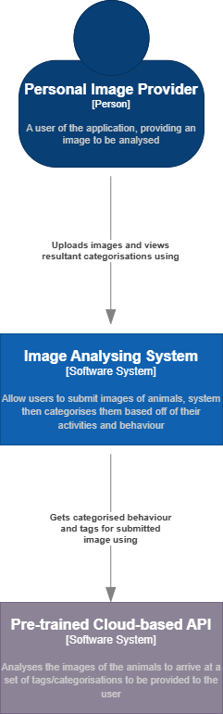

## C4 Container Diagram (level 2):

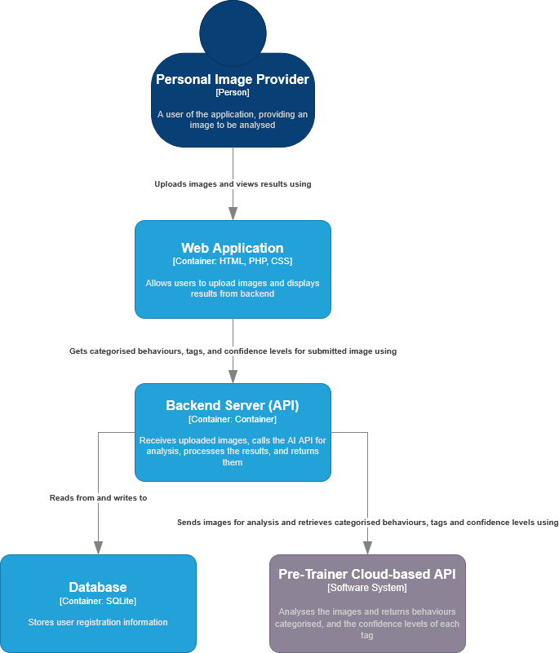

# Appendix 1: Tasks Completed

*Table 1-Tasks Completed by each Member:*

| Name: | Tasks Completed: |
| --- | --- |
| Alex Pantus | * Non-functional requirements, MoSCoW, User Stories |
|  |  |
|  |  |

# Appendix 2: GitHub Repository

Add here a link to your GitHub Repository.

*Table 2 - GitHub Usernames*

| **Student name** | **GitHub name** |
| --- | --- |
| Ariba Naveed | meariba123 |
| Alex Pantus | AlexPantusUni |
| Lenisha Kehoe | LenishaK |
| Ben McDonnell | benmaxmcd |
| Seb Tarabadi | sebtarabadi |

# References